# Adding an employee

1. Press The “Add Employee” button from the navigation bar.



1. Insert the information of the new employee in the form.

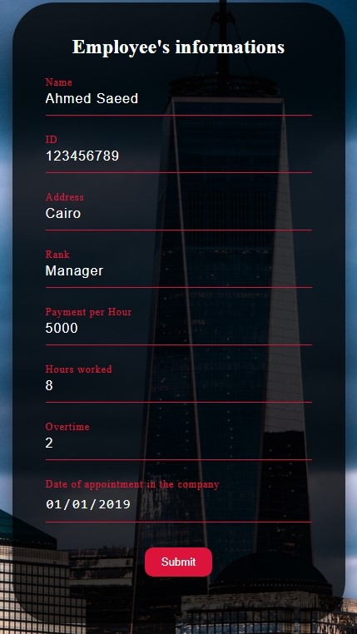

1. Press the submit button and a confirmation message will show.

# Displaying all employees

* + Press the “report button in the navigation bar and a table with all information will appear.

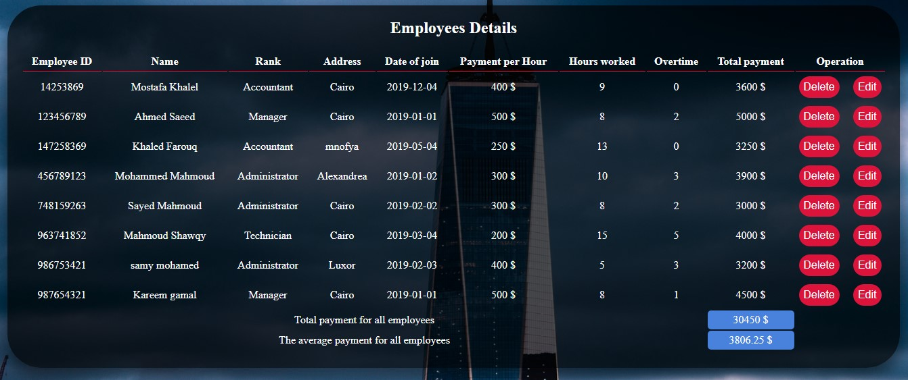

# Deleting an employee from the database system

1. Press the “Report” button in the navigation bar.
2. Press the delete button in front of the employee you want to delete from the “Operations” column.
3. 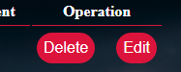A confirmation message will appear, press Delete to confirm or cancel to decline.



# Editing an existed employee

1. Press the “Report” button from the navigation bar
2. Press the “Edit” button in front of the employee you want to edit his information.
3. 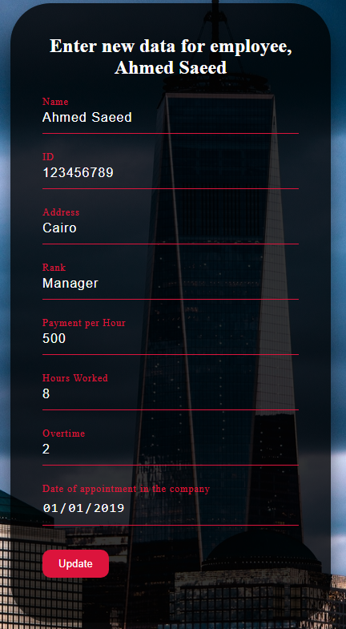Enter the new information in the form and press update.

# Searching for an employee

1. Press the “Search by ID” button in the navigation bar.
2. Enter the ID of the employee you’re looking for in the box.

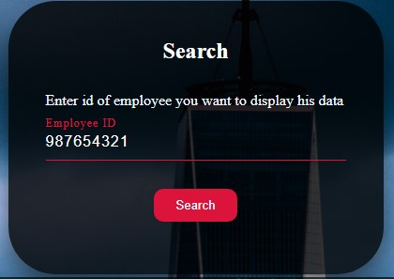

1. A table with all employee’s information will appear.

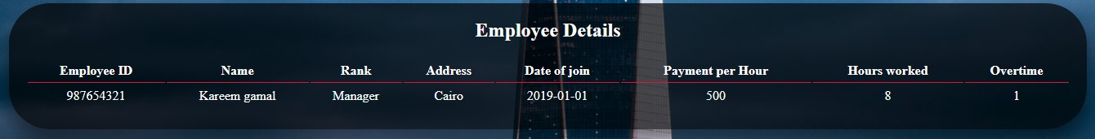

* If the ID entered doesn’t exist in the database system an error message will appear.

